**GUI**

**tkinter** module

from tkinter import *

win = Tk()

win.title("Python GUI")

win.mainloop()

from tkinter import *

#Tkinter is a Python library that can be used to construct basic graphical user interface (GUI) applications.

win = Tk()

# create an instance(object) of the Tk class by calling its constructor to create a tkinter application, we generally create an instance of tkinter frame, i.e., Tk().

#It helps to display the root window and manages all the other components of the tkinter application.

win.title("Python GUI")

# use the instance variable of the class (win)

#to give our window a title via the title property.

##win.resizable(0, 0)

# Disable resizing the GUI - enable and show this in the lecture

win.mainloop()

**win.resizable(0, 0) - will stop from resizing the window**

**Comment this line - win.resizable(0, 0) – can resize the window**

**Note:**

**For any widget to be seen on the output window, may you either use pack() or grid() immediately after the widget is defined in the code**

**#pack(): Places the label in the window.**

**#win.mainloop(): Starts the GUI event loop, allowing interaction.**

**Label Widget**

from tkinter import *

win = Tk()

win.title("Python GUI – Label Widget")

mylabel = Label(win, text="SY BSc(IT)") #defined the label

#Label is a **widget class** provided by the tkinter module and uses the Tk instance as its **parent container**.

mylabel.pack()

win.mainloop()

from tkinter import *

win = Tk()

win.title("Python GUI")

mylabel1 = Label(win, text="Hello SY BSc(IT) Students")

mylabel2 = Label(win, text="Python was started as a hobby project by Rossum as a summer project")

mylabel1.grid(row =0, column =0)

mylabel2.grid(row =1, column =0)

win.mainloop()

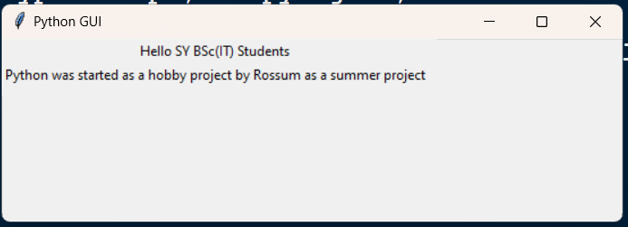

from tkinter import *

win = Tk()

win.title("Python GUI")

mylabel1 = Label(win, text="Hello SY BSc(IT) Students")

mylabel2 = Label(win, text="Python was started as a hobby project by Rossum as a summer project")

mylabel3 = Label(win, text="Happy to Teach youuuuuuuuuuuu Students")

mylabel4 = Label(win, text="Pythonnnnnn was started as a hobbyyyyyyyy project by Rossum as a summer project")

mylabel1.grid(row =0, column =0)

mylabel2.grid(row =1, column =0)

mylabel3.grid(row =2, column =0)

mylabel4.grid(row =3, column =0)

win.mainloop()

Remove mylabel3 and myabel4 and do the following:

**Change the below**

mylabel2.grid(row =1, column =0)

**to**

mylabel2.grid(row =1, column =1)

**Change the below**

mylabel2.grid(row =1, column =0)

**to**

mylabel2.grid(row =1, column =5)

**you get to see the same output because they are relative to each other**

**instead add the below and see the difference……**

from tkinter import *

win = Tk()

win.title("Python GUI")

mylabel1 = Label(win, text="Hello SY BSc(IT) Students")

mylabel2 = Label(win, text=" ")

mylabel3 = Label(win, text="Python was started as a hobby project by Rossum as a summer project")

mylabel1.grid(row =0, column =0)

mylabel2.grid(row =1, column =1)

mylabel3.grid(row =1, column =5)

win.mainloop()

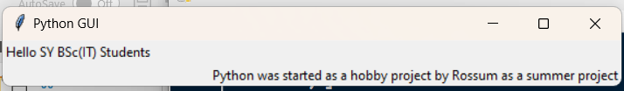

**Or**

**Can combine the label and grid functions……as seen below**

mylabel1 = Label(win, text="Hello SY BSc(IT) Students").grid(row =0, column =0)

mylabel2 = Label(win, text=" ").grid(row =1, column =1)

mylabel3 = Label(win, text="Python was started as a hobby project by Rossum as a summer project").grid(row =1, column =5)

**Button Widget**

from tkinter import *

win = Tk()

win.title("Python GUI")

#the action to be performed on clicking a button to be written inside a function, here it is myclick()

def myclick():

mylabel = Label(win, text = "Oh! I clicked a Button.")

mylabel.pack()

mybutton = Button(win,text = "Click Me", state = DISABLED, padx = 50,pady = 50, command = myclick,

fg = "white", bg = "black")

mybutton.pack()

win.mainloop()

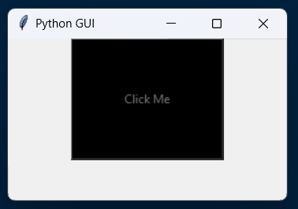

**Remove state**

**Add () after the function name in Button statement……..that is** **command = myclick()**

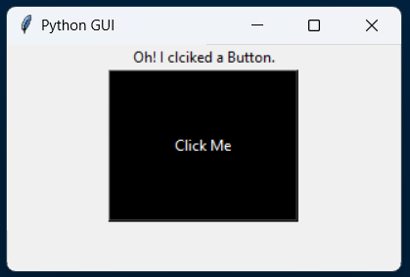

Here padx and pady is used to increase or decrease the length and breadth of the widget Button

from tkinter import *

win = Tk()

win.title("Python GUI")

def myclick():

mylabel = Label(win, text = "Oh! I clciked a Button.", **font = ("Times New Roman", 12, "bold"))**

mylabel.pack()

mybutton = Button(win,text = "Click Me", padx = 50,pady = 20, command = myclick(),

fg = "yellow", bg = "black", **font = ("Times New Roman", 18, "bold"))**

mybutton.pack()

win.mainloop()

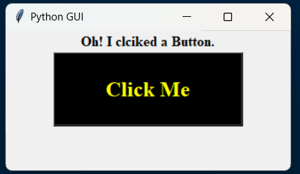

**Remove () and see the below output……..**

